NOMBRE: ___________________________________________________________________

Actividad: Reconozco la funcion de las partes del computador, en este caso el teclado.

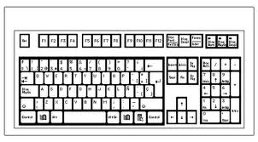

1. ______________________________________________________________
2. ______________________________________________________________
3. ______________________________________________________________
4. ______________________________________________________________