NOMBRE: ___________________________________________________________________

Actividad: Establezcoa relacion de la calculadora con la tecnología..

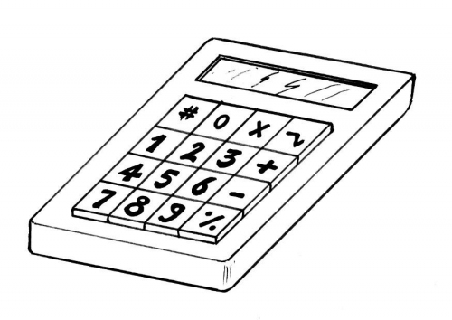

1. ______________________________________________________________
2. ______________________________________________________________
3. ______________________________________________________________
4. ______________________________________________________________